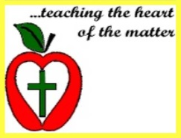
My Thoughts About Sunday Mass
This is the day that the Lord has made. Let us be glad and rejoice in it.
Psalm 118:24

Child’s Name
Grade
Church Attended
Mass Attended (check one) Saturday Evening Sunday
Liturgy of the Word for Children yes no
Name of Priest
Write and draw a picture of something about the Gospel.

